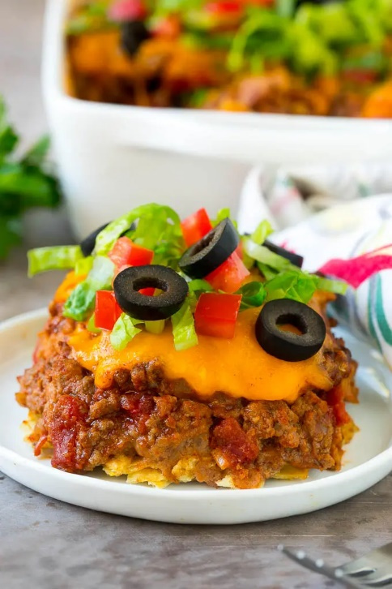
Taco Casserole
Prep time 15 min Cook time 30 min
4 Servings
Ingredients
2 teaspoons olive oil
1 lb ground beef
½ cup onion finely diced
1 packet taco seasoning
14.5 ounce can diced tomatoes do not drain
1 ¼ cups tortilla chips crushed
16 ounce can refried beans (optional)
1 ¼ cups cheddar cheese shredded
Toppings such as shredded lettuce, diced tomatoes, salsa, sour cream and sliced olives
Directions
- Preheat the oven to 350 degrees. Coat a 9-inch square pan or 2-quart baking dish with cooking spray.
- Heat the olive oil in a large skillet over medium high heat. Add the ground beef and cook for 5 to 6 minutes, breaking up the meat with a spatula.
- Add the onion and cook for an additional 3 to 4 minutes or until onion is translucent.
- Stir in the taco seasoning and diced tomatoes. Simmer for 3 to 4 minutes.
- Place a layer of tortilla chips in the bottom of the prepared pan. Spread a layer of refried beans over the top.
- Pour the beef mixture over the beans and top with the cheese.
- Bake for 4 to 5 minutes or until cheese is melted.
- Add toppings if desired, then serve.
Notes
Instead of crushed tortilla chips, try Nacho Doritos
Serve refried beans on side
Instead of diced tomatoes, you can substitute salsa

